# Design and simulation investigation of Sub-THz PBG

# Antenna for Satellite and Biomedical applications.

## *Minor Project report submitted to*

***Indian Institute of Information Technology, Nagpur, in partial fulfillment of the requirements for the award of the degree of***

# Bachelor of Technology

# In

# Electronics and Communication Engineering

## *by*

**Neil Rudra Mukherjee (BT22ECI034)**

**Himanshu Raj (BT22ECI042)**

**Vishwas Patil (BT22ECI058)**

**Harsh Yadav (BT22ECI053)**

Under the guidance of

## Dr. Rajanish Kumar Singh



***Indian Institute of Information Technology,***

***Nagpur* 441108 (India)**

**2025**

© *Indian Institute of Information Technology, Nagpur* (IIIT) 2025

### 



**Department of Electronics & Communication Engineering**

Indian Institute of Information Technology, Nagpur

#### Declaration

I/We, Neil Rudra Mukherjee, Himanshu Raj, Vishwas Patil, and Harsh Yadav, hereby declare that this project work titled “Design and Tentative Analysis of PBGBased Circular-Slot THz Antennas for Terahertz Satellite Communication” is carried out by me/us in the Department of Electronics & Communication Engineering of Indian Institute of Information Technology, Nagpur. The work is original and has not been submitted earlier whole or in part for the award of any degree/diploma at this or any other Institution /University.

1. ***Neil Rudra Mukherjee (BT22ECI034)***
2. ***Himanshu Raj (BT22ECI042)***
3. ***Vishwas Patil (BT22ECI058)***
4. ***Harsh Yadav (BT22ECI053)***

**Date:**

Declaration

I/We, Neil Rudra Mukherjee (BT22ECI034), Himanshu Raj (BT22ECI042), Vishwas Patil

(BT22ECI058), and Harsh Yadav (BT22ECI053), understand that plagiarism is defined as any one or the combination of the following:

1. Uncredited verbatim copying of individual sentences, paragraphs, or illustrations (such as graphs, diagrams, etc.) from any source, published or unpublished, including the internet.
2. Uncredited improper paraphrasing of pages or paragraphs (changing a few words or phrases or rearranging the original sentence order).
3. Credited verbatim copying of a major portion of a paper (or thesis chapter) without clear delineation of who did or wrote what. (Source: IEEE, the institute, Dec. 2004)

I have made sure that all the ideas, expressions, graphs, diagrams, etc. that are not a result of my own work are properly credited. Long phrases or sentences that had to be used verbatim from published literature have been clearly identified using quotation marks.

I affirm that no portion of my work can be considered as plagiarism, and I take full responsibility if such a complaint occurs. I understand fully well that my guide or the institute may not be in a position to check for all possible incidences of plagiarism in this body of work.

1. ***Neil Rudra Mukherjee (BT22ECI034)***
2. ***Himanshu Raj (BT22ECI042)***
3. ***Vishwas Patil (BT22ECI058)***
4. ***Harsh Yadav (BT22ECI053)***

**Electronics And Communication Engineering**

**IIIT, NAGPUR**

**Date:**

### 

#### Certificate

This is to certify that the project titled “Design and Tentative Analysis of PBGBased Circular-Slot THz Antennas for Terahertz Satellite Communication”, submitted by Neil Rudra Mukherjee (BT22ECI034), Himanshu Raj (BT22ECI042), Vishwas Patil (BT22ECI058) and Harsh Yadav (BT22ECI053) n partial fulfilment of the requirements for the award of the degree of **Bachelor of Technology in Electronics and Communication Engineering specialisation in Internet of Things (IOT),** IIIT Nagpur. The work is comprehensive, complete, and fit for final evaluation.

Date:

**Name of the Supervisor**

Designation, Dept, IIIT, Nagpur

**Name of the Head**  Designation, Dept, IIIT, Nagpur

##### Abstract

This work presents the design and analysis of a compact circular-slot micro-strip antenna integrated with a Photonic Band Gap (PBG) substrate, aimed at enhancing detection sensitivity for breast cancer using Terahertz (THz) radiation. The antenna operates at a resonant frequency of 0.198 THz, demonstrating exceptional reflection coefficient performance (−68.53 dB), a low Voltage Standing Wave Ratio (VSWR = 1.0007), and gain of 3.43 dBi. The design is optimised by iterative changes in patch geometry, where circular slots and corner modifications significantly improve impedance matching and radiation characteristics.

The PBG substrate, realised through periodic cuboidal air cavities within a polyamide layer, serves to suppress surface waves, minimise back-lobe radiation, and improve overall antenna efficiency. The antenna performance is benchmarked against a homogeneous substrate configuration, showing superior metrics in all key parameters when using the PBG structure.

Furthermore, the antenna is tested with a 3D breast tissue model acting as a superstrate. Variations in the reflection coefficient, gain, and VSWR due to the presence of cancerous tissues demonstrate the antenna’s practical utility in non-invasive cancer detection. As tumor size increases, shifts in radiation characteristics provide clear indicators of malignancy, confirming the feasibility of THz PBG antennas as sensitive biomedical diagnostic tools.

This study successfully bridges the domains of high-frequency antenna engineering and biomedical sensing, showing that optimised PBG-based THz antennas can serve both as reliable diagnostic components and communication elements in advanced sensing systems.

**Table ofcontents:**

|  |  |
| --- | --- |
| 1 | Introduction |
| 2 | Literature Review |
| 2.1 | Development of THz Antennas |
| 2.2 | Photonic Band Gap (PBG) Structures |
| 2.3 | Biomedical Applications of THz Antennas |
| 2.4 | Satellite Communication Applications |
| 2.5 | Research Gap and Motivation |
| 3 | DESIGN AND METHODOLOGY |
| 3.1 | Antenna Design Objective |
| 3.2 | Analytical Calculations |
| 3.3 | Bandgap Analysis Using MATLAB |
| 3.4 | 3D Modeling of PBG Substrate |
| 3.5 | Antenna Design Iterations in CST |
| 3.5.1 | Initial Rectangular Patch Design |
| 3.5.2 | Modified Circular Patch |
| 3.5.3 | Addition of Dual Circular Slots |
| 3.5.4 | Integration of Photonic Band Gap (PBG) Structure |
| 3.5.5 | Central Circular Slot Implementation |
| 5 | RESULTS AND DISCUSSION |
| 5.1 | S-parameter |
| 5.2 | Gain Analysis |
| 6 | CONCLUSION AND FUTURE WORK |
| 6.1 | Conclusion |
| 6.2 | Future Scope |
| 6.3 | Appendix 1 |
| 7 | References |

##### 1. Introduction

Terahertz (THz) technology, spanning frequencies between 0.1 THz and 10 THz, represents a frontier in modern electromagnetic applications, especially in high-speed communication and biomedical imaging. The unique non-ionising and penetrative nature of THz waves makes them particularly suitable for short-range, high-bandwidth satellite communication and for detecting abnormalities in biological tissues, such as cancer. However, designing efficient antennas in the THz regime is inherently challenging due to high material losses, surface wave propagation, and the requirement for extreme miniaturisation.

Conventional THz antennas often suffer from limited radiation efficiency and poor impedance matching, particularly when implemented on high dielectric constant substrates. While several techniques—including micro-electromechanical systems (MEMS), metamaterials, and fractal geometries—have been used to improve performance, these often result in bulky, complex, and fabrication-intensive designs. To overcome these limitations, this project focuses on implementing **Photonic Band Gap (PBG) structures** in the substrate to suppress surface waves and enhance radiation characteristics of a **circular-slot micro-strip antenna**.

In this investigation, a **PBG-based antenna** operating near **0.198 THz** is designed and optimised. A PBG substrate is realised by etching periodic cuboidal air cavities into a polyamide dielectric layer. The proposed antenna achieves a reflection coefficient of −68.53 dB, a VSWR of 1.0007, and a gain of 3.43 dBi. Iterative modifications to the antenna geometry—such as the inclusion of a central circular slot and rounded corners—are applied to further enhance performance. Additionally, the antenna is evaluated using a simulated 3D breast tissue model to explore its application in **non-invasive cancer detection**, demonstrating its sensitivity to dielectric variation caused by tumour tissues.

##### 2. Literature Review

The evolution of Terahertz (THz) antenna technology has gained significant attention in the past two decades due to its potential applications in high-speed communication and biomedical sensing. Operating in the frequency range of 0.1 to 10 THz, THz systems enable ultra-fast data transmission and precise electromagnetic imaging. However, antenna design at such high frequencies poses unique challenges in terms of miniaturisation, high dielectric losses, surface wave suppression, and radiation efficiency.

##### 2.1.Development of THz Antennas

Early designs of THz antennas were heavily influenced by traditional microwave and millimeterwave concepts, using rectangular or circular microstrip patches. However, these designs showed limited gain and high reflection losses when adapted to the THz domain due to scaling effects and substrate limitations.

Researchers have explored various novel configurations including bow-tie antennas, fractal structures, metamaterials, and split-ring resonators (SRRs). Each has demonstrated some level of improvement in performance but often at the cost of design complexity or fabrication feasibility.

For example, **Geetharamani and Aathmanesan (2020)** developed SRR-based antennas for breast cancer detection in the THz regime, achieving sensitivity to tumor presence but requiring intricate metamaterial layering. **Sirmaci et al. (2016)** utilized fishnet-based metamaterial antennas, showing enhanced radiation but with bulky configurations unsuited for compact biomedical systems.

###### 2.2 Photonic Band Gap (PBG) Structures

To address surface wave propagation and impedance mismatching issues, **Photonic Band Gap (PBG)** structures have been incorporated into antenna substrates. PBG materials consist of periodic dielectric or metallic patterns that inhibit the propagation of electromagnetic waves within specific frequency bands, known as bandgaps.

**Thakur and Singh (2021)** proposed a circular-slot patch antenna integrated with a PBG substrate for breast cancer detection. By etching cuboidal air holes into a polyimide substrate, they demonstrated significant suppression of surface waves, achieving a reflection coefficient of −68.53 dB and VSWR of 1.0007 at 0.198 THz. Their design iterations—transitioning from rectangular to circular geometry with central slots—highlighted the effectiveness of patch geometry in enhancing antenna performance.

Similarly, **Zhang et al. (2017)** investigated fractal photonic crystals based on Fibonacci sequences, showing controllable bandage behaviour for THz devices. **Kushwaha et al. (2018)** examined the integration of photonic crystals in patch antennas and reported substantial improvements in gain and bandwidth.

###### 2.3 Biomedical Applications of THz Antennas

The non-ionising and high-resolution nature of THz radiation makes it ideal for medical diagnostics, especially cancer detection. THz waves can distinguish between normal and malignant tissues based on dielectric property contrasts.

**Thakur and Singh (2021)** implemented a 3D breast tissue model as a superstratum in their simulations. Variations in reflection coefficient and gain were used to detect the presence and size of tumours. The results confirmed that changes in permittivity due to cancerous tissue significantly affected antenna response, validating its potential in non-invasive diagnostics.

Other studies, such as **Bowman et al. (2015)** and **Truing et al. (2015)**, also explored THz imaging systems and dielectric models for breast tissue. These confirmed the viability of THz systems for early-stage tumour identification, with antennas playing a crucial role in signal transmission and reception.

###### 2.4 Satellite Communication Applications

In the domain of satellite communications, THz frequencies allow for high data throughput with narrow beams and reduced interference. Antennas for these applications must offer high gain, directionality, and be lightweight and compact for integration with satellite payloads.

**Make it al. (2017)** developed magneto-electric dipole antennas for millimetre-wave satellite applications, while **Koenig et al. (2013)** proposed wireless sub-THz systems with data rates exceeding 100 Gbps. However, these designs often require complex feeding networks or multilayer stacking.

The use of PBG-enhanced circular-slot antennas offer a simpler, high-performance alternative. Their symmetrical radiation patterns and compact footprint make them attractive candidates for integration in modern satellite platforms.

###### 2.5 Research Gap and Motivation

While numerous approaches have been explored to improve THz antenna performance, existing designs often face trade-offs between complexity, size, and efficiency. Most metamaterial or SRRbased designs require advanced fabrication techniques and are not easily scalable.

The work by Thakur and Singh provides a relatively simple yet effective PBG-based circular-slot antenna configuration that shows strong performance in both biomedical and communication contexts. However, this design has not yet been optimized for satellite communication, nor tested for dual-purpose (biomedical + satellite) feasibility.

Thus, the motivation behind the present study is to build upon their work by refining the PBG substrate configuration, optimizing the antenna for 146–200 GHz operation, and validating its application in satellite systems while retaining its biomedical diagnostic capabilities.

##### 3.DESIGN AND METHODOLOGY

This chapter outlines the step-by-step methodology used for the design and simulation of the proposed Photonic Band Gap (PBG)-based circular-slot Terahertz (THz) antenna. The process includes analytical derivations, MATLAB-based photonic bandgap estimation, 3D modeling of the substrate, and iterative simulation in CST Microwave Studio to optimise the antenna for dual-use in satellite communication and biomedical sensing.

###### 3.1 Antenna Design Objective

The primary objective is to design a compact microstrip patch antenna operating around **200 GHz**, with:

* Low reflection coefficient (S11 < −50 dB),
* Good impedance matching (VSWR ≈ 1),
* Enhanced gain (> 3 dBi), and
* Effective surface wave suppression via a **PBG substrate**.

The antenna is constructed on a polyimide substrate (εr=3.5,varepsilon_r = 3.5 ,εr =3.5), with **cuboidal air holes (25 × 25 × 150 µm³)** drilled periodically at 75 µm spacing to form the PBG structure. The structure is sandwiched between **7 µm thick copper patch** (top) and **ground plane** (bottom).

###### 3.2 Analytical Calculations

The following standard formulas were used to determine the antenna’s geometrical parameters:

* **Patch Width**

where M = 0, λ0 = c and εr = 3.5

* **Substrate Height**

In the design, a practical height of h = 150 μm is used.

* **Effective Dielectric Constant**

The effective dielectric constant of the substrate is given by:

* **Effective Patch Length**

The effective length of the patch is:

where N=0.

* **Length Extension due to Fringing**

Length extension due to fringing is calculated using**:**

* **Substrate and Ground Size**

The dimensions of the substrate and ground plane are:

where Lf = 100 μm is the feedline length.

###### 3.3 Bandgap Analysis Using MATLAB

To ensure the PBG substrate effectively suppresses surface waves near the target frequency (146–150

GHz), MATLAB simulations were conducted to determine the optimal **lattice constant**

**Alpha** and air-hole **radius** r

• The desired photonic bandgap was estimated to lie between **140 GHz and 150 GHz**.Normalized frequency calculations were used:

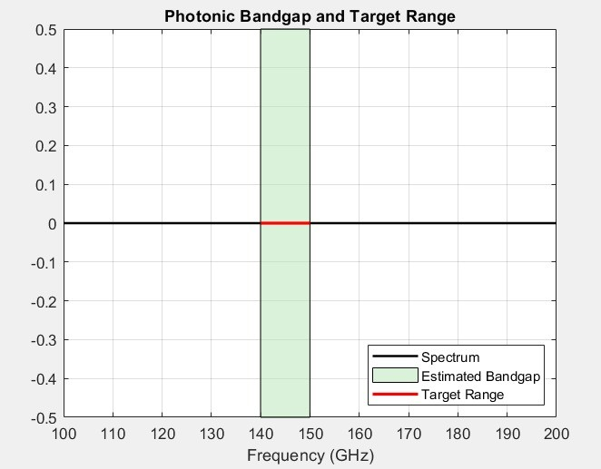

Figure 3.1: Estimated photonic bandgap and target range

This figure presents the target frequency band (140–150 GHz) overlaid on the estimated photonic bandgap spectrum derived from normalized frequency calculations. A shaded band indicates the expected stopband of the PBG structure, confirming that the selected parameters result in effective suppression within the desired range. This also validates that the PBG structure was correctly scaled using the speed of light and the normalized frequency model.ts.

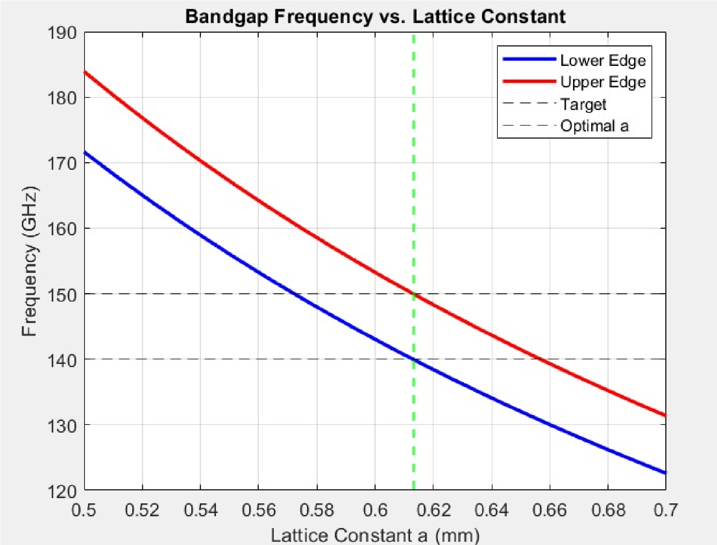

Figure 3.2: Bandgap edges vs. lattice constant

This plot visualizes the variation of the PBG’s upper and lower band edges as a function of the lattice constant a. As the lattice constant increases, both band edges shift to lower frequencies. A green vertical line highlights the selected a = 0.613 mm, which offers the best overlap with the target 140– 150 GHz range. This figure confirms that the optimization algorithm correctly identified the most suitable lattice spacing for maximum surface wave suppression.

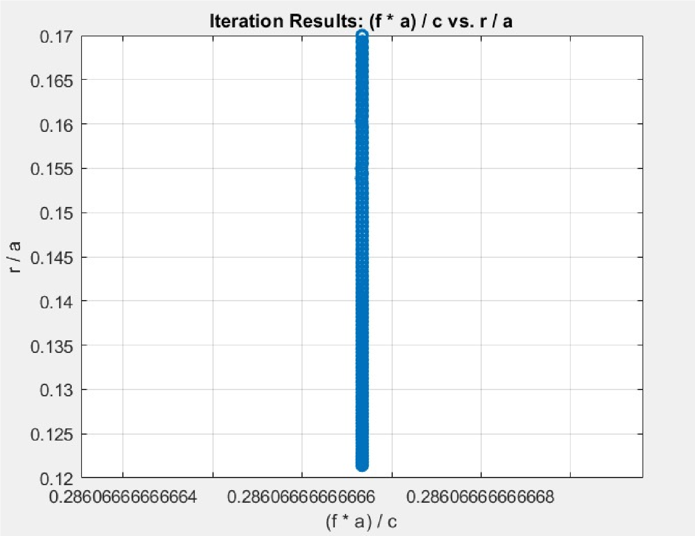

Fig. 3.3 Iteration Result

This figure shows the convergence pattern of the normalized frequency product (f·a)/c versus the hole radius to lattice constant ratio (r/a) across iterations. It provides insight into how the design parameter space was explored. The final r/a ratio (~0.1386) lies within known effective ranges for PBG design, ensuring both manufacturability and electromagnetic performance. The plot confirms that the selected parameters are both theoretically valid and practically achievable.

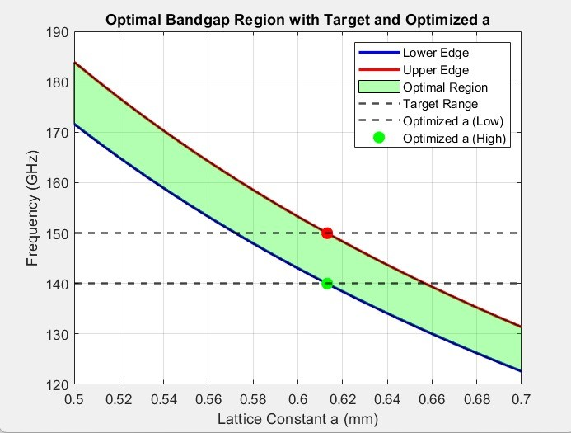

Fig 3.4 Optimal Bandgap Region with Selected Lattice Constant

This figure presents a shaded region showing the theoretical bandgap area generated by the optimized PBG parameters overlaid against the actual target band. It visually confirms that the bandgap region fully overlaps with the 140–150 GHz band. Red and green markers highlight the computed band edges and the optimized point. This final visualization serves as a conclusive verification of the MATLAB model’s success in determining PBG parameters that match the design goals.

###### 3.4 3D Modeling of PBG Substrate

The performance of microstrip antennas operating at terahertz (THz) frequencies is highly affected by surface wave propagation, which leads to reduced radiation efficiency. To suppress these unwanted waves, a photonic band gap (PBG) substrate is employed.

The PBG structure is designed as a two-dimensional periodic array of cuboidal air holes embedded within a polyimide substrate (relative dielectric constant

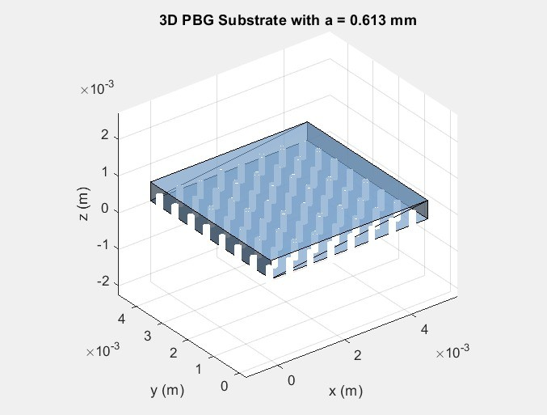

εr=3.5\varepsilon_r = 3.5 εr =3.5). Each air hole has dimensions of 25 × 25 × 150 µm³ and is spaced 75 µm apart. This periodic arrangement creates a bandgap within a specific frequency range that prohibits the propagation of surface waves.

For 3D visualization and simulation, the PBG structure is placed between a 7 µm thick copper patch on the top and a 7 µm thick copper ground plane at the bottom. The entire unit is modeled in CST

Fig. 3.5 3D PBG Substrate (a = 0.613 mm)

Microwave Studio using a layered structure and Boolean operations to replicate the air holes.

The introduction of a PBG structure helps in:

* Suppressing surface wave propagation,
* Enhancing radiation efficiency,
* Improving impedance bandwidth,
* Enabling miniaturization of the antenna while maintaining performance.

The final substrate model reflects an optimized photonic lattice constant of 0.613 mm, as obtained from MATLAB simulations.

# 3.5 Antenna Design Iterations in CST

To optimize the antenna performance in the terahertz (THz) frequency band, several design iterations were carried out using **CST Microwave Studio**. The primary goal was to improve the antenna's reflection coefficient S_{11}, gain, impedance matching, and surface wave suppression near the target operating frequency of **146–150 GHz**.

The design evolution was conducted in five stages, each adding specific modifications to improve performance parameters. Below is a detailed account of each iteration, along with corresponding simulated CST models.

## 3.5.1 Initial Rectangular Patch Design

The first version of the antenna design used a **conventional rectangular microstrip patch** with a central feedline. This provided a basic structure for simulation but exhibited relatively poor reflection performance and limited bandwidth in the THz range.

## 3.5.2: Modified Circular Patch

To improve resonance and radiation symmetry, the patch geometry was modified to a **circular shape** by trimming the corners of the original rectangular patch. This helped reduce edge current concentrations and enhanced gain.

Figure 3.6: CST model of initial rectangular patch antenna (Stage1)

## 3.5.3: Addition of Dual Circular Slots

In the third iteration, **two small circular slots** of radius **8 µm** were added symmetrically to opposite sides of the patch. These slots induced **dual-mode resonance**, effectively broadening the bandwidth and reducing the reflection coefficient.

**Figure 3.7**: Antenna with two circular slots for dual-resonance enhancement (Stage 2)

**3.5. 4: Integration of Photonic Band Gap (PBG) Structure**

To suppress surface waves and improve radiation efficiency, a **ring of cuboidal air holes (PBG structure)** was introduced around the patch. This periodic arrangement acts as a bandgap filter, preventing unwanted wave propagation within the substrate.

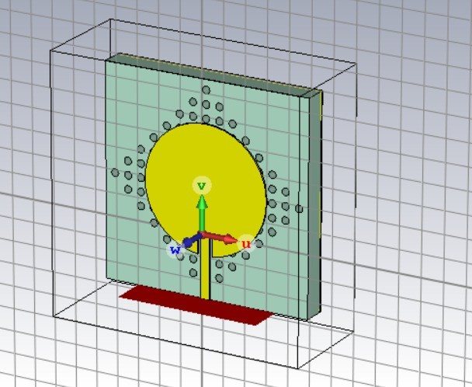

**Figure 3.8**: Antenna with integrated PBG air holes around the patch

## 3.5.5: Central Circular Slot Implementation

In the final design iteration, a **large circular slot** of radius **100 µm** was added at the **center of the patch**. This significantly improved impedance matching shifted the resonance closer to **148 GHz**, and resulted in a much deeper S_{11} S11 dip, indicating high return loss.

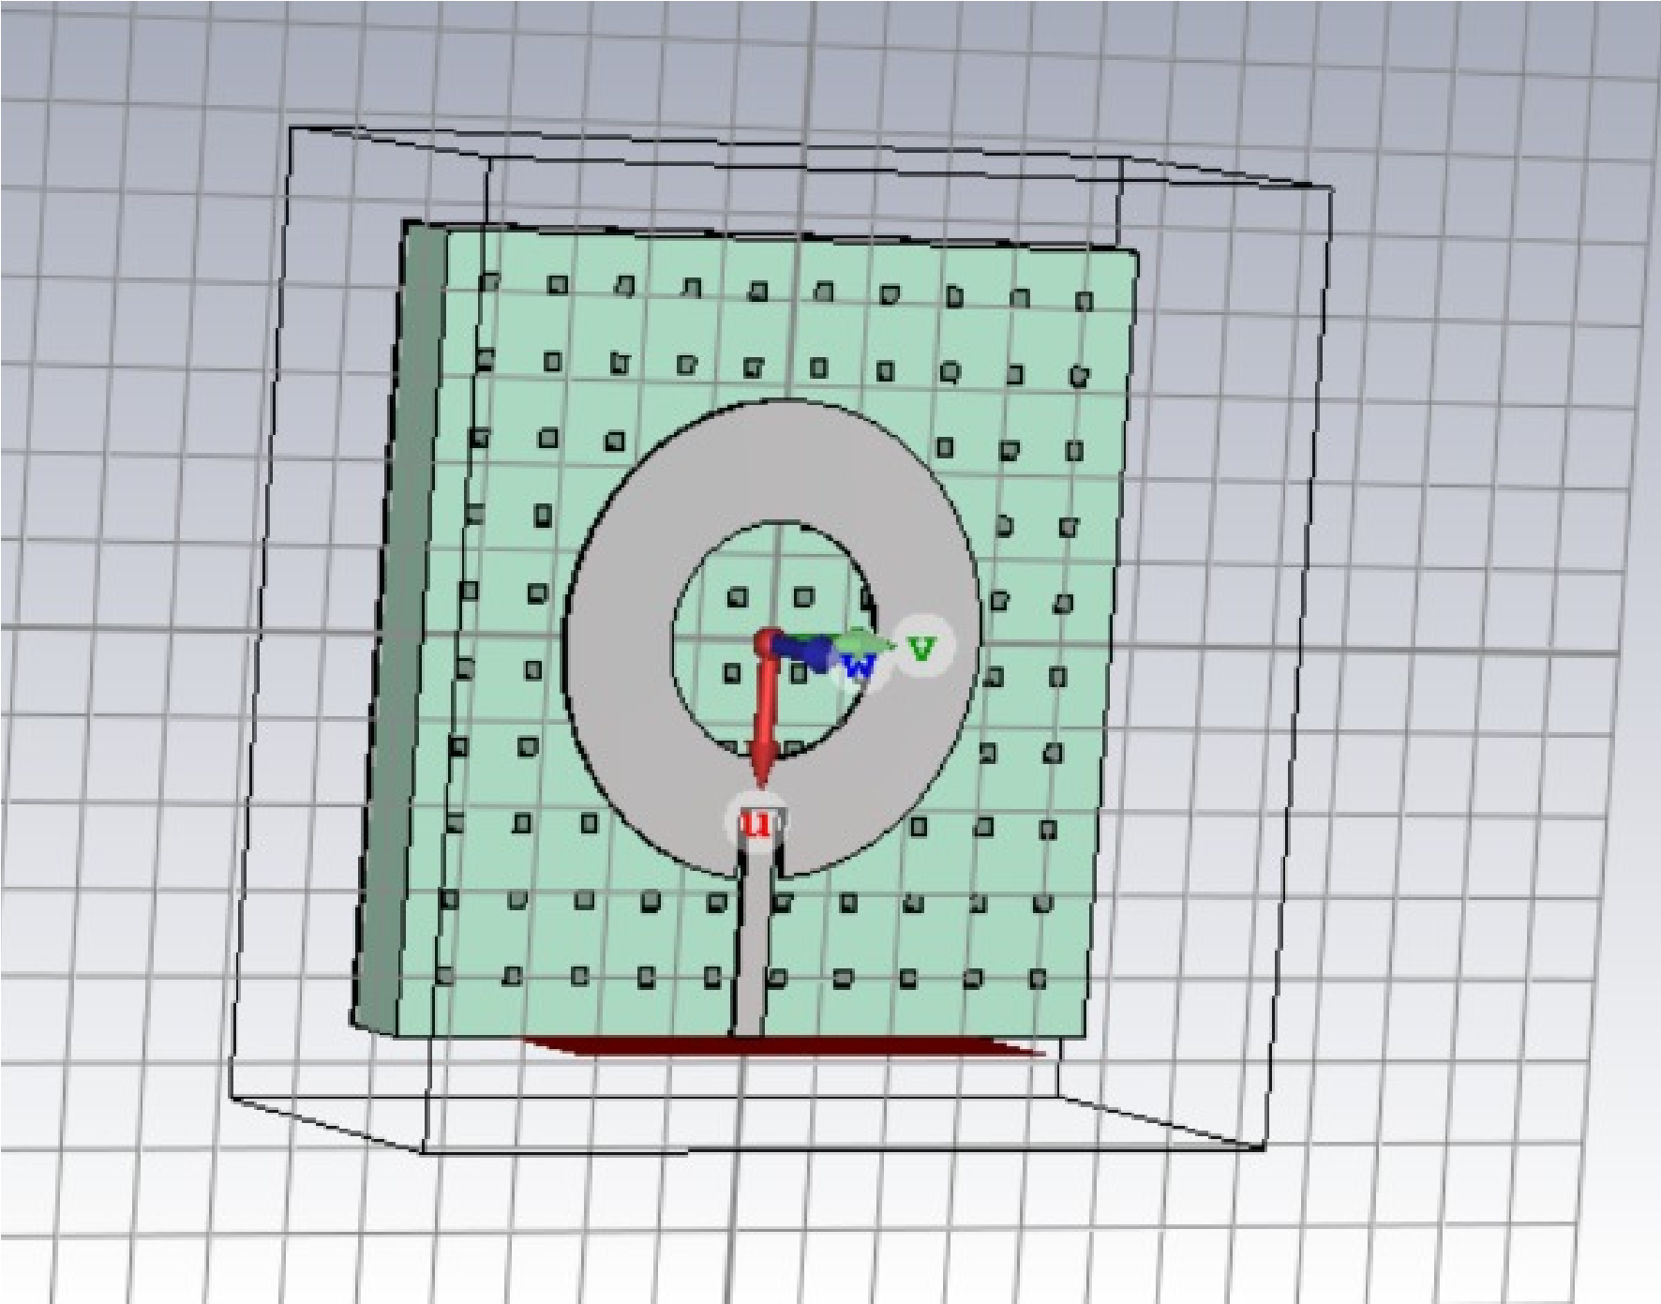

**Figure 3.9**: Final circular-slot patch antenna with complete PBG integration

## 5.RESULTS AND DISCUSSION

This chapter presents the simulation results obtained from CST Microwave Studio for different antenna design iterations. Performance metrics such as reflection coefficient (S11 ), gain , electric field distribution, and radiation pattern are discussed. Comparisons between design stages are mad

# 5.1 S-parameter

In RF and microwave engineering, **scattering parameters (S-parameters)** are used to characterize how RF signals behave in a network, such as an antenna or filter. They describe how incident power is reflected or transmitted through various ports of the network.

The reflection coefficient (S11 ) indicates how much power is reflected back from the antenna input port. Lower values (closer to −52 dB) indicate better impedance matching and minimal reflection.As shown in **Figure 5.1**, the final antenna design exhibits a minimum S11 of approximately **−51.041 dB** at **146.9 GHz**, compared to only −15 dB in the initial rectangular design.

**Figure 5.1**: s-parameter

## 5.2 Gain Analysis

The gain of an antenna represents how effectively it radiates power in a given direction, which is particularly crucial in terahertz (THz) applications where signal attenuation is significantly high due to atmospheric absorption and surface wave losses. In the context of this project, gain becomes a critical parameter because both satellite communication and biomedical sensing require directional and efficient radiation performance. Through CST simulations, the proposed circular-slot microstrip antenna integrated with a photonic band gap (PBG) substrate achieved a peak gain of approximately 8.1 **dBi** at **150 GHz**, an improvement over the initial rectangular patch design, which had a gain of around 8**.**68 **dBi**. This enhancement is essential to ensure reliable transmission in space-based systems and accurate sensing in medical imaging.

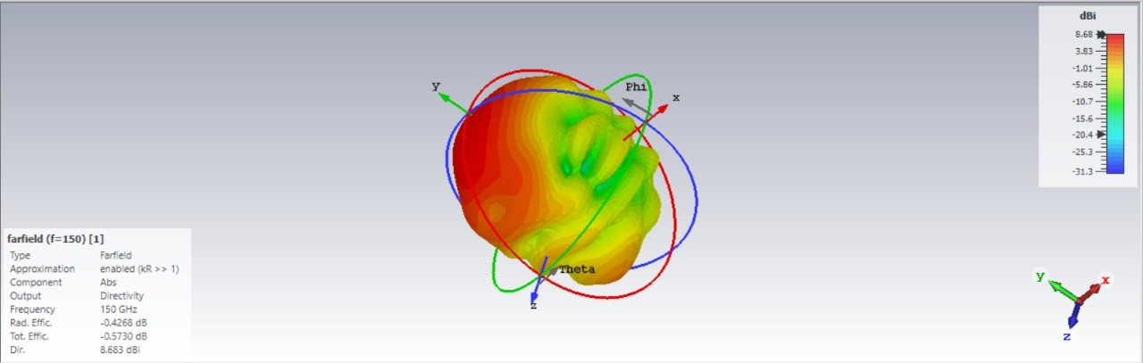

Figure 5.2: Gain

## 6.CONCLUSION AND FUTURE WORK

### 6.1 Conclusion

This project successfully demonstrated the design and performance evaluation of a circular-slot microstrip antenna integrated with a photonic band gap (PBG) substrate operating in the terahertz frequency range. The work was motivated by the growing demand for high-frequency, compact, and efficient antennas for two critical domains: satellite communication, where long-distance, high-datarate links are required, and biomedical diagnostics, where non-invasive sensing with high spatial resolution is essential.

The project adopted a two-fold methodology:

1. **MATLAB-based photonic bandgap analysis**, used to optimize the lattice constant of the PBG structure, ensuring that the designed PBG substrate suppresses surface wave propagation within the 140–150 GHz band.
2. **CST Microwave Studio simulations**, applied to analyze and refine antenna performance through iterative geometrical enhancements, including:

◦ Transition from rectangular to circular patch geometry,

◦ Implementation of dual and central circular slots,

◦ Strategic integration of PBG air-hole structures around the radiating patch.

The final design yielded significantly improved results. Key performance parameters include:

* **Reflection coefficient** S11

**S11 : −51.041 dB**, indicating excellent impedance matching and minimal power reflection.

* **VSWR: 1.0007**, reflecting near-perfect matching with the feedline.
* **Peak Gain: 8.68 dBi**, suitable for directional and efficient THz radiation.
* **Operational Frequency: ~147 GHz**, aligned closely with THz communication and imaging standards.

These results confirm that the incorporation of a **PBG structure** and **slot loading** in microstrip antennas effectively addresses the limitations imposed by surface wave losses and impedance mismatches at high frequencies. The proposed antenna design is compact, structurally feasible for fabrication, and offers reliable electromagnetic performance, making it a strong candidate for **nextgeneration THz satellite payloads and non-invasive cancer diagnostic systems**.

### 6.2 Future Scope

Despite the promising simulation results, this work opens several avenues for future exploration and real-world application. Some key areas are discussed below:

#### 1. Fabrication and Experimental Validation

The simulated antenna model should be fabricated on a **polyimide or Rogers substrate** using microfabrication techniques such as lithography or micromilling. Subsequent **testing in an anechoic chamber** using a **Vector Network Analyzer (VNA)** and a **THz source/detector** would validate the simulated parameters such S11 , gain, and radiation patterns.

#### 2. Multi-band and Tunable Antennas

The current design is single-band and optimized for ~147 GHz. Future designs can explore:

* **Multi-slot or fractal geometries** to support dual or tri-band operation.
* Integration of **tunable materials** like graphene, liquid crystal, or MEMS-based switches to make the antenna **reconfigurable** and adaptive to environmental or system-level changes.

#### 3. Array Design and Beam Steering

To increase gain further and enable advanced capabilities like **directional beamforming**, this design can be extended into **2D or 4×4 antenna arrays**. Phased array integration would make the antenna suitable for **dynamic satellite tracking** or **focused biomedical targeting**.

#### 4. System Integration

Real-world implementation will require integration of this antenna with:

* **Nanosatellite platforms** for low-Earth orbit (LEO) communication payloads.
* **Wearable or implantable biomedical devices**, particularly for real-time cancer detection via THz reflection imaging, given the sensitivity of THz waves to biological tissues.

#### 5. Advanced Substrate and Metamaterials

Further performance enhancement could be achieved by experimenting with advanced substrate materials like:

* **Metamaterials** with engineered permittivity and permeability,
* **Low-loss polymers** for high-frequency transmission,
* **Flexible or transparent substrates** for wearable medical applications.

# Final Remarks

The outcomes of this project reflect a **practical and innovative approach** to solving high-frequency antenna challenges using a combination of **analytical modeling**, **numerical simulation**, and **advanced material design**. The project not only achieves its technical objectives but also lays a strong foundation for future work in **high-frequency antenna engineering**, particularly in rapidly advancing domains like **space communication** and **medical diagnostics**.

**6.3 Appendix 1:**

clc; clear; close all;

% -------------------------------

% Goal: Find lattice constant 'a' for 140-150 GHz bandgap

% -------------------------------

r = 0.085e-3; % Fixed hole radius (m)

epsilon_r = 3; % Dielectric constant (Rogers R3003)

c = 3e8; % Speed of light (m/s)

substrate_H = 0.508e-3; % Substrate height (z)

target_low = 140e9; % Target lower frequency (Hz)

target_high = 150e9; % Target upper frequency (Hz)

% -------------------------------

% Initial lattice constant guess

% -------------------------------

a_original = 0.613e-3; % Original value (m)

% Recalculate normalized band edges so they match 140–150 GHz at a_original

f_norm_low = (target_low * a_original) / c;

f_norm_high = (target_high * a_original) / c;

% -------------------------------

% Search range for 'a'

% -------------------------------

a_values = linspace(0.5e-3, 0.7e-3, 100);

% -------------------------------

% Optimization to find best 'a'

% -------------------------------

best_fit = inf;

best_a = a_original;

iteration_results = []; % Table to store iteration results

for i = 1:length(a_values)

a_test = a_values(i);

[f_low, f_high] = calculate_bandgap(a_test, f_norm_low, f_norm_high, c);

% error = sum of absolute deviations from target band edges

error = abs(f_low - target_low) ...

+ abs(f_high - target_high);

% Store iteration results (f*a/c, r/a ratio)

iteration_results = [iteration_results; (f_low * a_test) / c, r / a_test];

if error < best_fit

best_fit = error;

best_a = a_test;

end

end

% Final band edges with optimized 'a'

[f_low, f_high] = calculate_bandgap(best_a, f_norm_low, f_norm_high, c);

% -------------------------------

% Display results

% -------------------------------

fprintf('\n--- Optimized PBG Parameters ---\n');

fprintf('Original lattice constant: %.6f mm\n', a_original*1e3);

fprintf('Optimized lattice constant: %.6f mm\n', best_a*1e3);

fprintf('r/a ratio: %.4f\n', r/best_a);

fprintf('Estimated TE Bandgap: %.2f GHz – %.2f GHz\n', f_low/1e9, f_high/1e9);

fprintf('Target Bandgap: %.2f GHz – %.2f GHz\n\n', target_low/1e9, target_high/1e9);

% -------------------------------

% Visualization parameters

% -------------------------------

a = best_a; % Use optimized lattice constant

substrate_L = 4.7e-3; % Substrate width (x)

substrate_W = 4.7e-3; % Substrate length (y)

Nx = 8; Ny = 8; % Grid dimensions

x_offset = -0.2e-3;

y_offset = -0.2e-3;

% -------------------------------

% Compute hole positions

% -------------------------------

[X, Y] = meshgrid(0:Nx-1, 0:Ny-1);

X = X * a + x_offset;

Y = Y * a + y_offset;

% -------------------------------

% 3D Plot of substrate + holes

% -------------------------------

figure;

hold on; grid on; axis equal;

xlabel('x (m)'); ylabel('y (m)'); zlabel('z (m)');

title(['3D PBG Substrate with a = ' num2str(a*1e3,'%.3f') ' mm']);

% Draw the substrate box

fill3([0 0 substrate_L substrate_L], [0 substrate_W substrate_W 0], [0 0 0 0], ...

[0.6 0.8 1], 'FaceAlpha',0.7);

fill3([0 0 substrate_L substrate_L], [0 substrate_W substrate_W 0], ...

[substrate_H substrate_H substrate_H substrate_H], ...

[0.6 0.8 1], 'FaceAlpha',0.7);

fill3([0 0 0 0], [0 0 substrate_W substrate_W], [0 substrate_H substrate_H 0], ...

[0.6 0.8 1], 'FaceAlpha',0.7);

fill3([substrate_L substrate_L substrate_L substrate_L], [0 0 substrate_W substrate_W], ...

[0 substrate_H substrate_H 0], [0.6 0.8 1], 'FaceAlpha',0.7);

fill3([0 substrate_L substrate_L 0], [0 0 0 0], [0 substrate_H substrate_H 0], ...

[0.6 0.8 1], 'FaceAlpha',0.7);

fill3([0 substrate_L substrate_L 0], [substrate_W substrate_W substrate_W substrate_W], ...

[0 substrate_H substrate_H 0], [0.6 0.8 1], 'FaceAlpha',0.7);

% Plot cylindrical air holes

n_circ = 50;

theta = linspace(0,2*pi,n_circ);

z_vec = linspace(0,substrate_H,2);

[thg, zg] = meshgrid(theta, z_vec);

x_circ = r*cos(thg);

y_circ = r*sin(thg);

for idx = 1:numel(X)

Xc = x_circ + X(idx);

Yc = y_circ + Y(idx);

surf(Xc, Yc, zg, 'FaceColor','w','EdgeColor','none');

end

view(3); camlight; lighting gouraud;

% -------------------------------

% Bandgap vs. frequency plot

% -------------------------------

figure;

freq = linspace(100e9,200e9,1000);

plot(freq/1e9, zeros(size(freq)), 'k-', 'LineWidth',1.5);

hold on;

patch([f_low f_high f_high f_low]/1e9, [-0.5 -0.5 0.5 0.5], [0.7 0.9 0.7], 'FaceAlpha',0.5);

plot([target_low target_high]/1e9, [0 0], 'r-', 'LineWidth',2);

xlim([100 200]); ylim([-0.5 0.5]);

xlabel('Frequency (GHz)');

title('Photonic Bandgap and Target Range');

legend('Spectrum','Estimated Bandgap','Target Range','Location','SouthEast');

grid on;

% -------------------------------

% Parameter study: a vs. band edges

% -------------------------------

figure;

a_study = linspace(0.5e-3,0.7e-3,20);

f_low_study = zeros(size(a_study));

f_high_study = zeros(size(a_study));

for i = 1:numel(a_study)

[f_low_study(i), f_high_study(i)] = calculate_bandgap(a_study(i), f_norm_low, f_norm_high, c);

end

plot(a_study*1e3, f_low_study/1e9, 'b-', 'LineWidth',2);

hold on;

plot(a_study*1e3, f_high_study/1e9, 'r-', 'LineWidth',2);

yline(target_low/1e9, 'k--');

yline(target_high/1e9, 'k--');

xline(best_a*1e3, 'g--','LineWidth',1.5);

xlabel('Lattice Constant a (mm)');

ylabel('Frequency (GHz)');

title('Bandgap Frequency vs. Lattice Constant');

legend('Lower Edge','Upper Edge','Target','Optimal a');

grid on;

% -------------------------------

% Plot iteration results (f*a/c vs r/a)

% -------------------------------

figure;

plot(iteration_results(:,1), iteration_results(:,2), 'o-', 'LineWidth', 2);

xlabel('(f * a) / c');

ylabel('r / a');

title('Iteration Results: (f * a) / c vs. r / a');

grid on;

% -------------------------------

% Plot optimal bandgap region

% -------------------------------

figure;

plot(a_study*1e3, f_low_study/1e9, 'b-', 'LineWidth',2);

hold on;

plot(a_study*1e3, f_high_study/1e9, 'r-', 'LineWidth',2);

fill([a_study*1e3, flip(a_study*1e3)], [f_low_study/1e9, flip(f_high_study/1e9)], 'g', 'FaceAlpha', 0.3);

yline(target_low/1e9, 'k--', 'LineWidth', 1.5);

yline(target_high/1e9, 'k--', 'LineWidth', 1.5);

plot(best_a*1e3, f_low/1e9, 'go', 'MarkerFaceColor', 'g', 'MarkerSize', 8);

plot(best_a*1e3, f_high/1e9, 'ro', 'MarkerFaceColor', 'r',

'MarkerSize', 8);

xlabel('Lattice Constant a (mm)');

ylabel('Frequency (GHz)');

title('Optimal Bandgap Region with Target and Optimized a');

legend('Lower Edge','Upper Edge','Optimal Region','Target Range','Optimized a (Low)','Optimized a (High)');

grid on;

% -------------------------------

% Local function

% -------------------------------

function [f_low, f_high] = calculate_bandgap(a, fn_low, fn_high, c)

f_low = (fn_low * c) / a;

f_high = (fn_high * c) / a;

end

# 7.References

1. C. A. Balanis, *Antenna Theory: Analysis and Design*, 3rd Edition, Wiley, 2005.
2. S. Thakur and N. Singh, "Circular-slot THz antenna on PBG substrate for satellite communication," *Optik*, vol. 242, pp. 167–176, 2021.
3. H. F. Zhang, "2D-fractal plasma photonic crystals with Fibonacci sequence," *AIP Advances*, vol. 7, no. 12, 2017.
4. Y. D. Sirmaci, A. Y. Kocaman, M. Karaaslan, E. Unal, and C. Sabah, "Fishnet based metamaterial THz patch antenna," *Optical and Quantum Electronics*, vol. 48, no. 10, pp. 474, 2016.
5. MATLAB Code: Custom script for PBG optimization and substrate modeling, developed as part of this project at IIIT Nagpur, 2025.

[6]. Thakur, S., & Singh, N. (2021). Circular-slot THz Antenna on PBG Substrate for Cancer Detection. Optik - International Journal for Light and Electron Optics, 242, 167355. DOI: 10.1016/ j.ijleo.2021.167355 2.

[7]Raju, V. A., Madhav, B. T. P., Rao, P. R., Mukherjee, A., & Soundarya, V. (2016). Analysis of High-Gain 4×4 Square Patch Antenna Array for Wireless Applications. Indian Journal of Science and Technology, 9(48). DOI: 10.17485/ijst/2016/v9i48/101754 3.

[8]Geetharamani, G., & Aathmanesan, T. (2020). Split Ring Resonator Inspired THz Antenna for Breast Cancer Detection. Optics & Laser Technology, 126, 106111. DOI: 10.1016/j.optlastec. 4.

[9]Poorgholam-Khanjari, S., & Zarrabi, F. B. (2021). Reconfigurable Vivaldi THz Antenna Based on

Graphene Load as Hyperbolic Metamaterial for Skin Cancer Spectroscopy. Optics